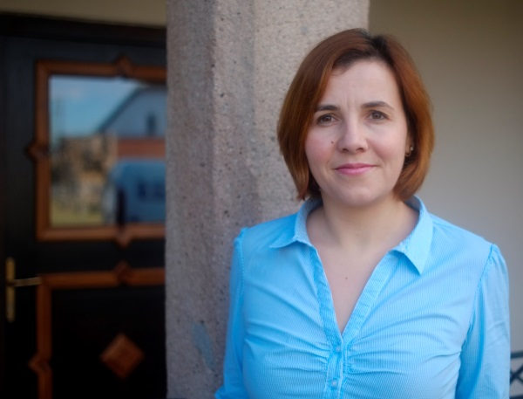
Lilla Rácz

Birth date : 2nd of January 1983
+40 721 93 44 46
lilla.racz@danielcastle.ro
5 Kalvin sqr., Sfantu Gheorghe, Covasna

Personal Profile
I find passion and personal fulfilment in fructifying the corporate business experience that I’ve accumulated over the last 10 years, in order to create value in the field of tourism and Transylvanian heritage valorification. As mother of 3 girls, I am happy to be able to role-model a lifestyle more anchored in traditional and human values. Professionally, I am interested in expanding the accumulated experience beyond the self-owned Daniel Castle project, and make a broader impact for the valorification of Transylvanian heritage and traditions.

Skills
Problem-solving, Broad-vision, Self-motivated, Collaborative, Leadership
Languages: Hungarian (native), Romanian (fluent), English (fluent), German (basic conversational)
Driving license

Work Experience
- Owner at Daniel Castle (Castle-Hotel: www.danielcastle.ro, cultural blog: www.1680.ro ) – since 2009
Coupling my passion for Transylvanian heritage with my international experience in marketing and business strategy development, to restore a 17th century Transylvanian castle, turning it into an economically self-sustaining castle-hotel.
Directly involved in, or personally implemented most steps of the process, from fund-raising (EU-FEADR and SEE Grants), restauration project management, business and marketing strategy development and implementation, to team-development and activity set-up.
Parallel with the implementation of the castle-hotel economic model, we also put emphasis on its cultural valorification with the Daniel Castle Association. I implemented several projects including historic exhibitions, scientific works and conferences, international art camps, and partnered with the local community for their cultural events.
Throughout these activities, I built a very diverse collaborative network of specialists, owners/managers of historic monuments, heritage and cultural organisations, artists and curators and local community influencers.

- Consumer and market knowledge manager at Procter & Gamble Marketing Romania , since Dec 2005, (on maternity leave since July 2014)
Vast consumer research and marketing consultancy experience through various assignments in the fields of:
- in-store marketing
- international product launches and strategy development, and
- marketing spend ROI and optimisation
Facilitated top-management strategic decision making through data-based and actionable strategy recommendations, and drove strategy implementation at mid-level. Experience of working with remotely located multidisciplinary and international teams.

Education and Training
Academy of Economic Studies, Faculty of International Business Relations, 2001 - 2005
Corporate trainings in the fields of: Effective Presentation, Coaching and Leadership

